Ex.no:5 | DATA VISUALIZATION USING MATPLOTLIB –  SALES DATA

Aim:
To visualize dataset features and distributions using line charts, bar charts, pie charts, histograms, scatter plots, and box plots using Matplotlib.

Algorithm:
ALGORITHM 1: LINE CHART
Objective: To visualize the monthly sales trend.
Steps
- Load the sales dataset.
- Select the Month and Sales columns.
- Plot the monthly sales using a line chart.
- Add title and axis labels.
- Display the graph.
Interpretation
The line chart shows how sales vary across different months and helps identify the sales trend.
# Program 1: Line Chart
plt.plot(months, sales)
plt.title("Monthly Sales")
plt.xlabel("Months")
plt.ylabel("Sales")
plt.show()

ALGORITHM 2: BAR CHART
Objective: To compare sales across different months.
Steps
- Select the Month and Sales columns.
- Create a bar chart using the monthly sales values.
- Add title and axis labels.
- Display the chart.
Interpretation
The bar chart helps compare the sales values across different months.
# Program 2: Bar Chart
plt.bar(months, sales)
plt.title("Monthly Sales")
plt.xlabel("Months")
plt.ylabel("Sales")
plt.show()

ALGORITHM 3: PIE CHART
Objective: To visualize the distribution of sales across different months.
Steps
- Select the sales values.
- Create a pie chart using the sales values.
- Display percentage labels.
- Add a suitable title.
- Display the chart.
Interpretation
The pie chart shows the percentage contribution of each month to the total sales.
# Program 3: Pie Chart
plt.pie(sales, labels=months, autopct="%1.1f%%")
plt.title("Sales Distribution")
plt.show()

ALGORITHM 4: HISTOGRAM
Objective: To visualize the distribution of sales values.
Steps
- Select the Sales column.
- Divide the sales values into bins.
- Create a histogram.
- Add title and axis labels.
- Display the histogram.
Interpretation
The histogram shows the frequency distribution of the monthly sales values.
# Program 4: Histogram
plt.hist(sales, bins=5)
plt.title("Sales Distribution")
plt.xlabel("Sales")
plt.ylabel("Frequency")
plt.show()

ALGORITHM 5: SCATTER PLOT
Objective: To visualize the sales values for different months.
Steps
- Select Month as the X-axis variable.
- Select Sales as the Y-axis variable.
- Create a scatter plot.
- Add title and axis labels.
- Display the graph.
Interpretation
The scatter plot shows the variation in sales across different months.
# Program 5: Scatter Plot
plt.scatter(months, sales)
plt.title("Monthly Sales")
plt.xlabel("Months")
plt.ylabel("Sales")
plt.show()

ALGORITHM 6: BOX PLOT
Objective: To visualize the distribution of monthly sales.
Steps
- Select the Sales column.
- Create a box plot.
- Add a suitable title and axis label.
- Display the plot.
Interpretation
The box plot shows the distribution of sales values and helps identify possible outliers.
# Program 6: Box Plot
plt.boxplot(sales)
plt.title("Sales Box Plot")
plt.ylabel("Sales")
plt.show()

ALGORITHM 7: MULTIPLE LINE CHARTS
Objective: To compare sales and profit across different months.
Steps
- Store the profit values.
- Plot the sales values using a line chart.
- Plot the profit values using another line chart.
- Add title, axis labels and legend.
- Display the graph.
Interpretation
The multiple line chart compares the sales and profit values across different months.
# Program 7: Multiple Line Charts
profit = [20, 30, 40, 35, 50, 60]

plt.plot(months, sales, label="Sales")
plt.plot(months, profit, label="Profit")
plt.title("Sales and Profit")
plt.xlabel("Months")
plt.ylabel("Value")
plt.legend()
plt.show()

Output:

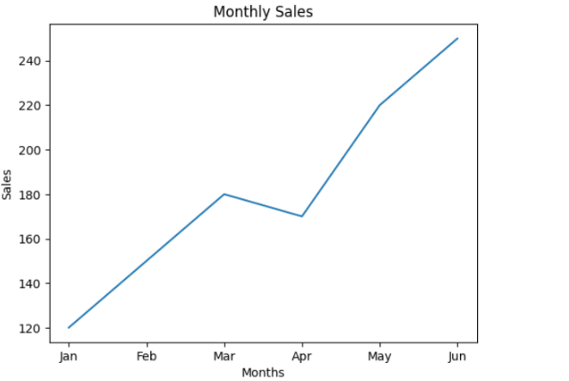

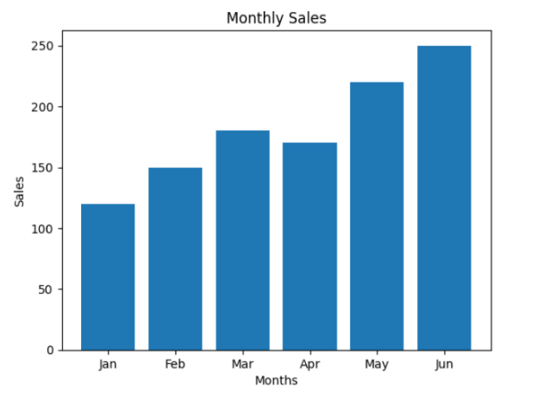

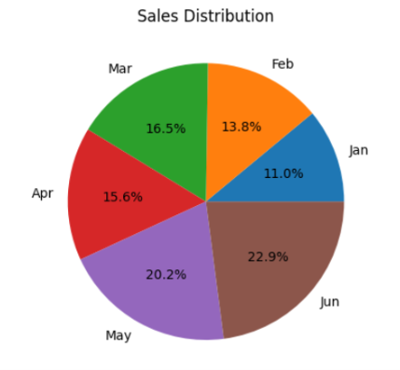

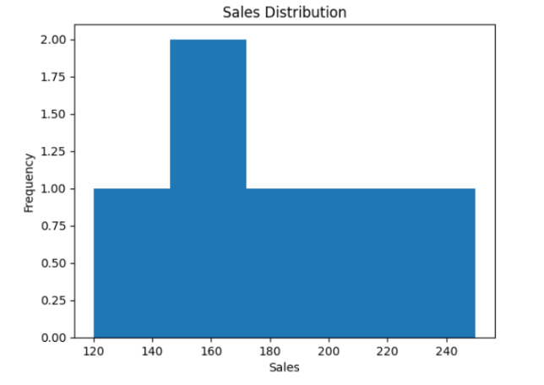

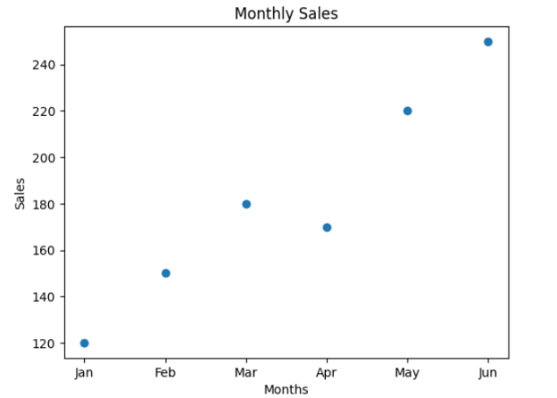

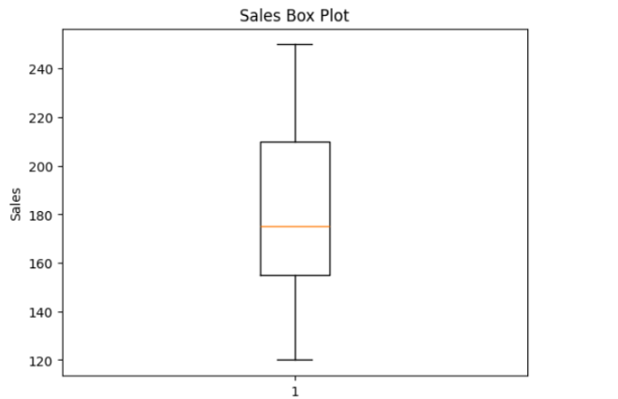

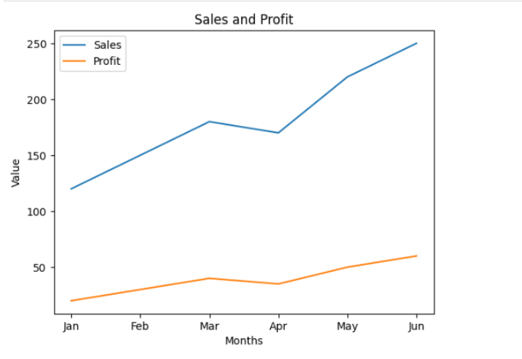

Result:

